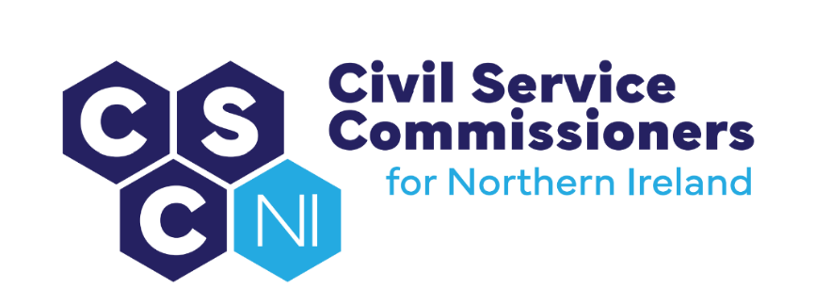

**civil Service Commissioners for Northern Ireland**

**Summary Record of Business Meeting**

**10am, Wednesday 9 April 2025**

**Erskine House, Belfast**

Attendees:

Commissioners – Deirdre Toner, Chairperson, Sinead Burns and Dr Lesley Carroll

Secretariat – Amanda Martin, Heather Caulfield, Dawn Molloy and Clair Hedley

Apologies: None

# Introduction and Pre-Meeting Business

The Chairperson welcomed everyone to the meeting.

Any other business

* There were no items of additional business.

Action Matrix from Business Meeting of 28.01.25 (Paper 1/25)

* Commissioners noted the update on the action points from the Business Meeting on 28.01.25.

Matters arising and Conflicts of Interest

* No conflicts of interest were declared in relation to the business meeting agenda and papers and there were no matters arising.

# Secretary’s Report (Paper 2/25)

The Secretary’s Report (copy previously circulated) was tabled and the following areas were highlighted:

## Engagement with NIO, Sponsor Body

* A recruitment campaign for a fourth Commissioner is to be launched in April/May 2025,with a view to interviews being held in June and the successful candidate being announced in August 2025.
* Commissioners’ Workshop, facilitated by ICS, will be held on 30 April 2025 to explore how they can strengthen their role in relation to recruitment and selection in the NICS.

Action: To arrange a meeting with the NIO Permanent Secretary and Sponsors in June 2025 to discuss the outcomes and the next steps.

## External Engagement Activity

### UK Civil Service Commission

* A meeting between Commissioners and the UK First Commissioner and Chief Executive has still to be arranged. Further, an invitation was issued to Commissioners to visit the UK Civil Service Commission later in 2025.

Action: As it has not been possible to identify a date for an online meeting, to instead seek to arrange a dedicated meeting with the Commission in London.

* On the 18 March 2025, Secretariat attended an online event entitled “Meet the Civil Service Commissioners: What to Expect from a Senior Civil Service application process”.

Action: To explore the logistics of Commissioners holding a public facing outreach event about their role later in the year.

### HOCS and Permanent Secretary, DoF

* Following Commissioners’ attendance at the Permanent Secretaries Stocktake Meeting on 28 February 2025, further meetings with individual Permanent Secretaries were arranged to discuss Commissioners’ draft Strategic Plan in more depth and to seek views on how Commissioners can best support the NICS to attract the most talented and diverse people and to encourage innovation and influence positive change in recruitment and selection.

Actions: (1) Secretary to follow up with the lead Permanent Secretary on the proposed Task and Finish group to streamline recruitment and selection; and (2) Secretariat to draft letters of thanks to all participating Permanent Secretaries.

### Recruitment and Selection Development Group (RSDG)

The RSDG met on 21 January 2025 and discussed:

* People Plan and People Strategy
* Pilot SCS Recruitment Process (Permanent Secretary and others)
* Temporary Promotions
* The next meeting which is scheduled to take place on 8 May 2025.

Action: Draft Agenda to be issued to NICSHR and People & OD

### NICSHR and People & OD

During this reporting period, Commissioners engaged, via correspondence and face to face, with NICSHR and P&OD on the following matters, as well as on other casework:-

* Amendments to Commissioners’ Recruitment Code
* Review of Article 6 Process
* Revised SCS Application Form
* Commissioners’ training video
* Consideration of use of Success Profiles
* Update from the NICSHR team
* Update on NIAO Review of Recommendations on Capacity and Capability in the NICS
* Audit Review Findings; and Audit Plan for 2025-26

## Equality, Diversity and Inclusion

* Following the award of Diversity Mark accreditation on 26 November 2024, a meeting has yet to be set up with the Independent Panel to discuss any support it could provide in the coming year.
* Diversity Mark accreditation is due for review in October 2025.
* Commissioners and the Secretariat attended a diversity themed lunch on 31 January 2025, which was hosted by Women in Business.
* An update was given on the recent review of Commissioners’ Equality Scheme and Action Plan and the policies which had been screened during Q1.
* The annual meeting with the Equality Commission was held on 6 February 2025.
* A Gender Diversity Workshop was hosted by Commissioners on 29 January 2025 followed by the Diversity and Inclusion meeting with People & OD colleagues.

## Audit Update

* Commissioners were reminded of the key outcomes from their dedicated Audit Meeting on the 31st January 2025. These included amendments to the Recruitment Code and Auditing for Improvement document which were sent to NICS for comment on 18 February 2025. Feedback had been received and was discussed at the meeting.

Action: Secretariat to draft letter of response to People & OD accordingly.

Commissioners noted the additional audit activity during the reporting period:

* the Audit and Engagement meeting was held with NICS colleagues on 26 February 2025 to discuss the findings from the Review of NICS Appointments below SCS made under Regulation 3(a) and the Audit Plan for 2025/26. They also discussed unregulated SIB appointments; and
* Commissioners met with NICSHR on 27 February 2025 to discuss the Article 6 Process and the improvement recommendations from the Article 6 Compliance Audits.

## Corporate Management and Governance

### Finance

* Commissioners were advised of the budgetary position at the end of Q4.

### Commissioners’ Business Plan 2024-25 – Quarter 4 Update:

* Commissioners were informed that all Q4 targets had been met with the exception of one Action 2.1 (Strategic Priority 2: People).

### Commissioners’ Strategic Plan 2025-2029

* Commissioners’ draft Strategic Plan had been circulated for targeted consultation on 6 January 2025 for an 8 week period. The closing date for comment was 12 noon on 3 March 2025.
* A plenary meeting with HOCS and colleagues in People and OD and NICSHR is to be arranged once all feedback has been considered.

Action: Arrange plenary meeting as described.

### Commissioners’ Business Plan 2025-26

* The Commissioners’ Business Plan 2025-26 will be influenced by the Strategic Plan which is still in draft form. The Plan will be finalised after the Commissioners’ workshop on 30 April.

### Learning and Development Plan 2024-25

* Commissioners’ were asked to complete mandatory Security and Data Protection training and sign off the Information Assurance Statement provided to them 30 April 2025.

Action: Commissioners to complete training module and return IAS.

### Corporate Risk Register

* The Secretariat further reviewed the Corporate Risk Register on 10 March 2025 to ensure it aligned with Commissioners’ Strategic Plan and its new priorities. Commissioners agreed to adopt the amended the risk descriptions reflecting their new priorities, subject to the word “influence” being omitted from CR3b and CR2.

Actions: Update risk descriptions accordingly; review mitigation measures and RAG status.

### Register of Recommendations from Reports including NIAO Report on Capacity and Capability in the NICS and PAC Report

* Commissioners noted the updated Report as reviewed by Secretariat on 20 March 2025. Reference was made to the current review of progress on the above Report being undertaken by NIAO with the NICS.

Action: Secretariat to seek an update on progress from NICS colleagues and enquire whether Commissioners will be included in the NIAO’s fieldwork.

### Communications

* The Commissioners’ “explainer guide” video has now been passed to NICS for inclusion in its recruitment and selection training package. There was a discussion about further videos that may be commissioned.

Action: The Secretary to draft a communications strategy for 2025-2026.

### Records Management

* The Secretariat has been in regular contact with PRONI to seek direction on the OCSC’s Retention and Disposal Schedule. It is hoped that there will be guidance from PRONI in the near future.

### 2024/25 Annual Report

* A timeline for the preparation and publication of the 2024/25 Annual Report was agreed at Commissioners’ Business Meeting in January. Commissioners were asked for their views on the key themes for inclusion.

Action: Commissioners to update their profiles for inclusion in the Annual Report.

### NICS Agency Workers Update

* It was noted that there has been a steady increase in the numbers of Agency Workers in NICS. This was raised briefly during the Commissioners meeting with the Permanent Secretary (DoF) on 12 March 2025 but Commissioners agreed to write to the Permanent Secretary on the matter.

Action: Secretariat to issue draft letter for Commissioners’ approval.

### Future Meetings

Commissioners’ provided their availability for May and June 2025 to enable the following future meetings to be arranged.

* with SIB Chief Executive
* EPIC Futures NI
* CPSA
* HOCS, People & OD and NICSHR (Plenary – Strategic Plan)
* NIO Permanent Secretary

**Actions:** (1) Arrange meetings accordingly; (2) Reschedule June Business Meeting to 19 June 2025.

## Housekeeping

## Register of Interests

* Commissioners were asked to advise the Secretariat of any updates.

**Office of the Civil Service Commissioners   
for Northern Ireland**