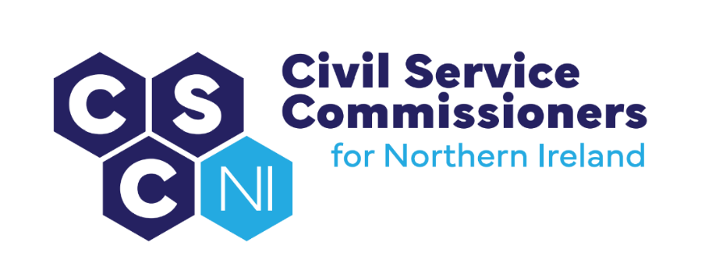

**BUSINESS PLAN 2025-2026**

**Strategic Priority 1: Safeguard the Merit Principle to Support an Impartial and Independent NICS**

|  |  |  |  |  |
| --- | --- | --- | --- | --- |
|  | **What?** | **How?** | **By When?** | **RAG Status (Q1)** |
| 1.1 | Maintain the principle of selection on merit | Publish v.16 of Recruitment Code (and review as required) | 31 May 2025 |  |
|  |  | Consider requests made by NICS to make appointments by way of Exception to the Merit Principle and issue decisions | Ongoing |  |
|  |  | Commissioners to chair all open SCS Recruitment Competitions | Ongoing |  |
|  |  | Commissioners to give Article 6 approval for SCS appointments | Ongoing |  |
|  |  | Seek and receive assurances from DoF that all recruitment activity is in compliance with current NICS Recruitment Policy and Procedures and with NICS Commissioners’ Recruitment Code | By 31 May 2025 (for the year 2024-2025) |  |
| 1.2 | Implement Audit Plan 2025-2026 to establish whether the Recruitment Code is being observed | Complete 2025-2026 Audit | By 31 March 2026 |  |
|  |  | Prepare and issue 2026-2027 Audit Plan to the NICS |  |  |
| 1.3 | Appendix C Data | Request the publication of data by the NICS (Appendix C of Commissioners’ Recruitment Code) to support Commissioners’ Annual Report |  |  |
|  |  | Publish Commissioners’ Annual Report | By 30 September 2025 |  |
| 1.4 | NICS Code of Ethics | Consider and determine appeals in accordance with Commissioners’ COE Guidance | Ongoing |  |
|  |  | Review Guidance | 31 March 2026 |  |

**Strategic Priority 2: Support the NICS to attract the most talented and diverse people**

|  |  |  |  |  |
| --- | --- | --- | --- | --- |
|  | **What?** | **How?** | **By When?/How often?** | **RAG Status** |
| 2.1 | Engage with the NICS | Meetings of the Recruitment and Selection Development Group | 4 per year |  |
|  |  | Participation in Task and Finish Groups | 3 currently ongoing |  |
|  |  | Meet with HOCS and Permanent Secretaries | At least Annually |  |
| 2.2 | Engage with other relevant bodies | Engage with the Strategic Investment Board to understand roles and responsibilities | By 31 July 2025 |  |
|  |  | Meet with Equality Commission for NI | By 31 March 2026 |  |
|  |  | Meet with S.75 Representative Groups and other groups to understand perspectives and barriers to recruitment | At least two annually by 31 March 2026 |  |
| 2.3 | Benchmark with and learn from other Commissions and sectors | Meet with UK Civil Service Commission | By 30 September 2025 |  |
|  |  | Meet with Commission for Public Service Appointments | By 31 December 2025 |  |
|  |  | Research the work of other Commissions | Meet with representatives of one additional Commission by 31 December 2025 |  |
|  |  | Research practice in other sectors | Meet with representatives from two private sector organisations by 31 March 2026 | 1. Microsoft |

**Strategic Priority 3: Encourage Innovation and Influence Positive Change in Recruitment to the NICS**

|  |  |  |  |  |
| --- | --- | --- | --- | --- |
|  | **What?** | **How?** | **By When/How Often?** | **RAG Status** |
| 3.1 | Review Commissioners’ legislative framework | Hold an internal workshop to identify areas where Commissioners may enhance their effectiveness | By 31 May 2025 |  |
|  |  | Meet with NIO Permanent Under Secretary and Sponsors to review roles and resources | By 31 August 2025 |  |
| 3.2 | Engagement with NICS | Meet with HOCS and NICS Board | At least annually by 31 March 2026 |  |
|  |  | Recruitment and Selection Development Group | 4 Meetings per year |  |
|  |  | Audit function to influence positive change | 2 Meetings per year |  |
|  |  | As Chairs of SCS recruitment Competitions, use Scoping Meetings to explore and influence use of innovative methods of recruiting | 80% of SCS competitionsby 31 March 2026 |  |
|  |  | Development video for inclusion in NICS’ Recruitment and Selection Training Package | By 31 May 2025 |  |
| 3.3 | Engagement beyond the NICS | Produce Introductory Video for Inclusion on Commissioners’ website | By 31 March 2026 |  |
|  |  | Host an event to highlight Commissioners’ Role and expectations to SCS candidates | By 31 March 2026 |  |

**Strategic Priority 4: Develop a diverse and supportive internal culture with an ethos of good governance**

|  |  |  |  |  |
| --- | --- | --- | --- | --- |
|  | **What?** | **How?** | **By When?/How Often?** | **RAG Status** |
| 4.1 | Discharge all statutory obligations | Publish an Equality Scheme | 1 April 2025 |  |
|  |  | Publish and Monitor Equality Action Plan | 31 March 2026 |  |
|  |  | Publish and Monitor Disability Action Plan | 31 March 2026 |  |
|  |  | Report to Equality Commission for NI | 31 August 2025 |  |
|  |  | Maintain a Retention and Disposal Schedule (awaiting approval by PRONI) | Ongoing |  |
|  |  | Process information in accordance with the Data Protection Act 2018 and GDPR | Ongoing |  |
|  |  | Respond to Requests for Information within statutory timescales (FOIA) | 100% |  |
| 4.2 | Comply with NIO Framework and HMT Managing Public Money | Monitor of budget allocation | 5% +/- budget variance  At 31 March 2026 |  |
|  |  | Publish Strategic Plan 2025-2029 | 30 June 2025 |  |
|  |  | Publish Business Plan 2025-2026 | 30 June 2025 |  |
|  |  | Hold a Business Planning Day | 30 November 2025 |  |
|  |  | Completion of Stewardship Statements (Mid Year and End of Year) | 31 October 2025 30 April 2026 |  |
| 4.3 | Learning and Development | All mandatory training completed by Commissioners and Secretariat | 100% by  31 March 2026 |  |
|  |  | 100% of performance reviews completed | 31 March 2026 |  |
|  |  | Induction training provided to new Commissioner | On appointment |  |
|  |  | Meet with representative groups | Two per year | 1. EPIC Futures |
| 4.4 | Diversity and Inclusion | Agree and publish a Diversity and Inclusion Strategy | 31 July 2025 |  |
|  |  | Review recruitment requirements and documentation for new recruits, including Commissioners | 30 April 2025 |  |
|  |  | Maintain Diversity Mark Accreditation | 31 October 2025 |  |