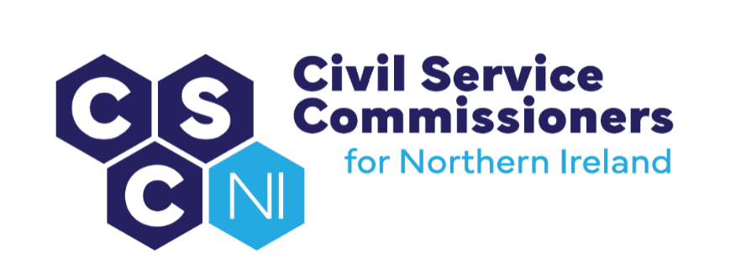

**civil Service Commissioners for Northern Ireland**

**Summary Record of Business Meeting**

**10am, Tuesday 9 September 2025**

**Erskine House, Belfast**

Attendees:

Commissioners: Sinead Burns, Chairperson, Dr Lesley Carroll

Secretariat: Amanda Martin, Heather Caulfield, Dawn Molloy

Apologies: Deirdre Toner

# Introduction and Pre-Meeting Business

The Chairperson welcomed everyone to the meeting.

Any other business

* There were no items of additional business.

Action Matrix from Business Meeting of 19.06.25 (Paper 10/25)

* Commissioners noted the update on the action points from the Business Meeting on 19.06.25.

Matters arising and Conflicts of Interest

* No conflicts of interest were declared in relation to the business meeting agenda and papers and there were no matters arising.

# Secretary’s Report (Paper 11/25)

The Secretary’s Report (copy previously circulated) was tabled and the following areas were highlighted:

UK Civil Service Commission

* Itineraries for Commissioners visit to the UK Civil Service Commission were distributed.

HOCS and Permanent Secretaries

* There was a discussion about the number of SIB personnel currently deployed in the NICS. It was agreed that the Secretariat would contact TEO for more information on these staff to enable clarification on those who are consultants and those who are temporary civil servants, appointed by Exception to Merit.

Recruitment and Selection Development Group (RSDG)

* There was discussion on the effectiveness of the RSDG meetings. Commissioners agreed that the Terms of Reference for these meetings should be reviewed and that the possibility of meeting with NICSHR and People and OD separately should be explored.

NICS Policy Task and Finish Groups

* Following a meeting held in May 2025 between Commissioners and senior officials from DfC and NICSHR on Streamlining Recruitment and Selection in the NICS, Commissioners have expressed their support for innovative initiatives to improve recruitment within the NICS. NICS have confirmed that they will test a 2-stage interview process for the current Permanent Secretary competition.

NICSHR and People & OD

* The Secretary provided a summary of the recent engagements with NICSHR and People & OD including
* Audit Work
* Internal Appointment – Assistant Chief Inspector (Grade 5) – DE
* Appointment of Regional Clinical Director of Elective Care – DoH
* Extension to secondment of Chief Medical Officer
* Proposed amendment to Recruitment Policy and Procedures Manual – Recruitment Advertising

Commission for Public Service Appointments

* It was confirmed that Commissioners will host representatives from the Commission for Public Service Appointments and Public Appointments Service in November 2025. People and OD/NICSHR are to be invited to participate.

Equality, Diversity and Inclusion

* Commissioners Diversity and Inclusion Strategy and Action Plan,which was compiled in line with Diversity Mark guidance, was discussed with Diversity Mark’s Head of Engagement in July 2025. OCSC will apply for reaccreditation in October 2025.

Finance

* Commissioners noted the budget as at the end of August 2025.

Business Planning

* It was agreed that representatives from Action for Children and Include Youth be invited to a future meeting with Commissioners to discuss access to work for young people from a care background.
* Commissioners were invited to consider video topics which could be impactful for their website. The Secretary advised that a software licence may be required for the generation of a video.
* The NICS has agreed that it would be open to Commissioners having a role in Panel Skills training for NICS staff. Commissioners’ involvement will be factored into the restructuring of this training, which is currently taking place.
* Commissioners were invited to comment on a brief which was put together for an online event for prospective candidates and a proposal to engage with NICSHR. Commissioners suggested that a focus group of recently promoted or appointed staff should be formed to determine what would be most beneficial to include in an upcoming online event.
* Commissioners and the Secretariat discussed the possibility of Commissioners chairing or observing external competitions below SCS. The Secretariat will explore the possibilities with NICSHR.

Corporate Risk Register

* The Secretariat proposed a small change to the risk status of a Corporate Risk in the Risk Register. Commissioners were content with the change.

Appointment of Commissioners

* Following an open recruitment competition, it was confirmed that two new Commissioners, appointed by Royal Warrant, would commence on 1 October 2025.

Staffing

* It was noted that the EO left the Secretariat at the beginning of July 2025. Recruitment of a new EO is currently ongoing.

2024/25 Annual Report

* Commissioners noted that their Annual Report 2024-25 was sent by post to HM The King and published on the website at the beginning of September 2025. Hard copies of the Report were distributed to Commissioners.

Review of Policy on Commissioners’ Fees Claims

* An updated policy on Commissioners' Fee Claims was presented to Commissioners. Following a brief discussion regarding the Commissioners' payment rates, the Secretariat will monitor Commissioners’ workload and liaise with the NIO.

Code of Ethics Casework

* One concern was raised under the NICS Code of Ethics in Quarter 2, relating to NICS participation in the Belfast Pride Parade 2025. Commissioners are currently exploring whether internal processes have been properly exhausted before considering whether to accept it as an Appeal under the NICS Code of Ethics.

# Audit Update

* Commissioners noted the update on Audit and were advised that all documentation will be forwarded to them prior to the dedicated Audit meeting in October 2025.

**Office of the Civil Service Commissioners   
for Northern Ireland**