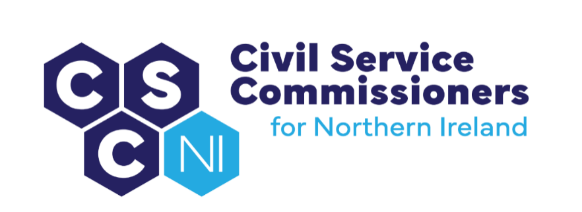

civil Service Commissioners for Northern Ireland
Summary Record of Business Meeting
10am, Friday 17 October 2025
Erskine House, Belfast

Attendees:

Commissioners: Deirdre Toner, Chairperson, Sinead Burns, Dr Lesley Carroll, David MacAnulty, Don Leeson

Secretariat: Amanda Martin, Heather Caulfield, Dawn Molloy

Apologies: None

Introduction and Pre-Meeting Business

The Chairperson welcomed everyone to the meeting including the new Commissioners, David MacAnulty and Don Leeson.

Any other business
- There were no items of additional business.

Action Matrix from Business Meeting of 09.09.25 (Paper 13/25)
- Commissioners noted the update on the action points from the Business Meeting on 09.09.25.

Matters arising and Conflicts of Interest
- No conflicts of interest were declared in relation to the business meeting agenda and papers and there were no matters arising.

Secretary’s Report (Paper 14/25)
The Secretary’s Report (copy previously circulated) was tabled and the following areas were highlighted:

Engagement with NIO, Sponsor Body

- The Secretary updated Commissioners on the new NIO contact for OCSC.

UK Civil Service Commission

- The Secretary explained to new Commissioners that incumbent Commissioners visited the First Commissioner, UK Civil Service Commission, in London on 15-16 September 2025. They also met with Cabinet Office officials (Government People Group) on the SCS Executive Search function and playbook. The Secretariat will forward the notes and accompanying slides from this visit to new Commissioners.

NICS Policy Task and Finish Groups

- Following background information provided by the Chairperson on the Task and Finish group for Streamlining Recruitment and Selection, it was agreed that Commissioners would seek a meeting with the lead Permanent Secretary for an update on progress.

NICSHR and People & OD

- Having liaised with People and Organisational Development, the Secretary explained that the possibility of Commissioners chairing a sample of competitions below SCS would be outside of policy and would have to be consulted on. It was suggested that Commissioners could continue to observe these competitions as part of the audit process.

Strategic Investment Board (SIB)

- The Secretary provided some background to SIB and their relationship with the NICS and an update was provided regarding the personnel from SIB who are currently deployed within the NICS.

Commission for Public Service Appointments

- An Agenda for the meeting scheduled with CPSA in November will be agreed and attendees confirmed also within the coming days.

Northern Ireland Audit Office

- Following Commissioners’ fieldwork engagement with the NIAO on the Review of the Report on Capacity and Capability in the NICS in May 2025, the Audit Office have advised that the Review Report is estimated to be published in late November 2025.

Diversity Mark

- Commissioners were reminded that a review of the OCSC’s accreditation is due for review by a Panel of independent assessors. Commissioners agreed that the application for reaccreditation should be submitted by the end of January 2026 to allow time for a comprehensive and robust application.

Corporate Risk Register

- Commissioners were advised that the Secretariat last reviewed the Risk Register on 28 August 2025 and Commissioners adopted proposed changes at their meeting on 9 September. The Risk Register will be reviewed in advance of Commissioners’ Business Meeting in January 2026.

Commissioners’ Webinar

- Commissioners agreed that a small amendment should be made to the draft invite to the focus group and that the invite should be sent to People & Organisational Development for their comments and advice on dissemination to the target audience.

Appointment of Commissioners

- Following an open recruitment competition, two new Commissioners, Don Leeson and David MacAnulty, commenced in post on 1 October 2025. Both attended an Induction session with the Secretariat on 10 October 2025 and arrangements are currently being made for new Commissioners to shadow incumbent Commissioners through the various stages of an SCS recruitment competition.

Staffing Update

- An Interchange competition was launched on 6 October 2025 to appoint an EO within OCSC. The application deadline is 27 October 2025.

Code of Ethics Casework

- It was agreed that the Secretariat would contact the DoF Nominated Officer (NICS Code of Ethics) for an update on the recent concern that was raised under the NICS Code of Ethics in Quarter 2.

Meeting with PRONI

- The Secretary recently met with PRONI and gained clarity around the legislation applicable to the OCSC’s Retention and Disposal schedule.. An updated Retention and Disposal schedule will be presented for sign-off at the Business Planning meeting in November and implementation will commence upon approval.

Future Meetings

- Commissioners agreed dates for multiple future meetings.

