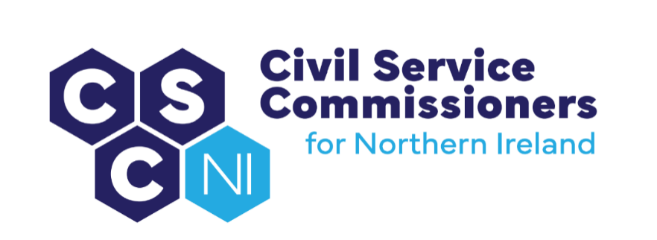

civil Service Commissioners for Northern Ireland
Summary Record of Business Meeting
10am, Thursday 22 January 2026
Andras House, Belfast

Attendees:

Commissioners: Deirdre Toner, Chairperson, Sinead Burns, Dr Lesley Carroll, David MacAnulty, Don Leeson (via Teams)

Secretariat: Amanda Martin, Heather Caulfield, Catherine Kirton, Dawn Molloy, Derek Keilty

Apologies: None

Introduction and Pre-Meeting Business

The Chairperson welcomed everyone to the meeting including new staff, Catherine Kirton and Derek Keilty.

Any other business
- There were no items of additional business.

Action Matrix from Business Meeting of 17.10.25 (Paper 15/25)
- Commissioners noted the update on the action points from the Business Meeting on 17.10.25.

Matters arising and Conflicts of Interest
- No conflicts of interest were declared in relation to the business meeting agenda and papers and there were no matters arising.

Secretary’s Report (Paper 16/25)

The Secretary’s Report (copy previously circulated) was tabled and the following areas were highlighted:

Engagement with HOCS and Permanent Secretaries

- Following the recent Permanent Secretary competition, it was agreed that Commissioners will meet with all new Permanent Secretaries when they have been appointed. In time, Commissioners will also meet with already established Permanent Secretaries.

Recruitment and Selection Development Group (RSDG)

- Commissioners were invited to identify items they wish to have included on the RSDG Agenda for the meeting scheduled for 12 February 2026.

Commission for Public Service Appointments (ROI)

- Commissioners were reminded that a visit from representatives from the Commission for Public Service Appointments and Public Appointments Service scheduled for 27 November 2025 has been rescheduled for 26 February 2026. Commissioners were informed that the new CEO of the PAS, Paul Geraghty, will also be in attendance. A final Agenda will be circulated mid-February.

Diversity Mark

- Commissioners considered the draft Diversity Mark application for reaccreditation and agreed that they were content for the application to be submitted by the deadline of 31 January 2026.

Equality

- Commissioners agreed that a previously arranged meeting with the Equality Commission (scheduled for 11 February 2026) should be rescheduled after the NICS Article 55 and Gender Review has been published.

- Commissioners were invited to suggest items for inclusion on the Agenda for Commissioners’ annual meeting with the Chief Commissioner and Chief Executive of the Equality Commission for NI. Commissioners were reminded that this will take place at 10:30am on 4 March 2026.

Diversity & Inclusion

- Commissioners were reminded that a meeting has been arranged with People & OD on 4 February 2026 and were invited to identify any items they would like added to the Agenda.
Guidance on Raising a Concern under the NICS Code of Ethics

- The Secretariat updated Guidance on Raising a Concern under the NICS Code of Ethics to make it clearer and more easily navigable. Guidance has since been equality screened and a copy forwarded to People & OD. It has also been published on the OCSC website along with an updated Easy Read version.

Business Planning

Actions from Internal Workshop of 30 April 2025

- It was agreed that Commissioners and Secretariat will meet soon to discuss video topics (including an introduction to CSC and “how to” guides) which could be impactful on the OCSC website.

- It was also agreed that an update on Commissioners having an active role in Panel Skills Training would be sought at the next Audit and Engagement meeting.

- Commissioners were reminded of the upcoming focus groups in February 2026. Preparation meetings will be arranged in advance and a briefing will be sent to Commissioners prior to the focus groups.

- Consideration of the benefits of having Link Commissioners aligned to “themes” will be deferred for discussion and included on the Agenda for April’s Business Meeting.

Commissioners’ Business Plan 2025-26
- Commissioners noted the Business Plan for 2025-2026 charting progress to date.

Commissioners’ Draft Business Plan 2026-27

- A draft outcomes-based Business Plan for 2026-2027 was considered by Commissioners. Commissioners suggested that Diversity Mark outcomes should be reflected in the Business Plan.

Draft Communications Strategy and Action Plan 2026-27

- Commissioners noted the draft Communications Strategy and Action Plan. Commissioners discussed their online presence and how to best represent themselves online. Colette Leeson will be invited to deliver a pro bono workshop on the effective use of LinkedIn.

Draft Learning and Development Plan 2026-2027

- Commissioners were content with the draft Learning and Development Plan for 2026 –2027.

Corporate Risk Register

- The Secretariat reviewed the Corporate Risk Register on 5 January 2026 and proposed changes, including a proposed change to the risk status of CR1. Commissioners were content with proposed changes.

Equality Action Plan & Disability Action Plan

- Given recent changes to Commissioners and Secretariat staffing, Secretariat has contacted the Equality Commission to arrange a training session on the equality and disability duties. A date will be confirmed in due course.

Commissioner Update

- Sinead Burns will finish her term as a Commissioner on 6 March 2026 after a period of 10 years.

2025/26 Annual Report

- Commissioners agreed the proposed timeline for the preparation and publication of the 2025/2026 Annual Report.

Casework

- Commissioners noted the ongoing casework. In relation to a recent notification of an internal appointment to a PPS role, it was agreed that a letter of response to NICSHR be drafted expressing Commissioners’ view that decisions to appoint through internal trawl must be supported by robust justification with regard to the unavailability of the necessary skills outside of the NICS.

Talent Management in the NICS and the Use of Merit Lists

- Commissioners discussed the potential for merit lists being used across departments.

